Chapter 2
Title: Study and Implementation of IoT Attendance System for Fingerprint Recognition

2.0 Overview
In today’s day and age, as technology is getting more advanced and humans have learned to incorporate it into their everyday activities like self-driving cars, 3D printing machines, vacuum robot and so on. However, there are some sectors that have not fully incorporated these technologies to maximize efficiency in areas like the education sectors for example, where the process of taking the attendance of students. This area can be further explored and enhanced using the technologies provided specifically one of the Industry Revolution 4.0 technologies, best known as the Internet of Things (IoT). If this technology were to be implemented efficiently it would surely without a doubt increase efficiency in terms of taking students’ attendance.

Thus, in this section of the documentation will be going through all the components needed in order to fully understand the theoretical part of the attendance system including the hardware, software, security risks of the system, and much more to implement a more well throughout attendance system. Moreover, the documentation will further discuss and explore on the future of the IoT technology that the direction it is going.

2.1 Internet of Things
This section of the documentation will be discussing about the Internet of things as it is one of the most revolutionary technologies to be introduced to mankind which had been applied in different sectors including agriculture, home automation, wearables and so on. According to an article published by Hercog,D. et al. published in July 2023 it has been said that a device can only be deemed as an Internet of Things if it has the following four characteristics which include the ability to collect data and transfer it to other devices or directly to the Internet, receive data from the network, belongs to the network that involves the communication of other devices.

Not only that, but it has also been emphasized by Prdyumna Gokhale, Omkar Bhat and Sagar Bhat in January 2018, that the IoT device is divided into four layers with the first layer being the sensing layer where devices are equipped with sensors that are capable of sense the environment and transmit data automatically with other devices. There are a few aspects that needs to be taken into consideration in order to decide on suitable sensing layer for the IoT device which includes the following:
- Cost, resources, energy consumption :
Where it the cost and resources are taken into consideration to develop a system the has the least demanding resources and costs

- Deployment: Where it involves one time deployment, incremental deployment or random deployment based on the requirements
- Communication: Where it involves easy access so that there is easy communication of the devices
- Network: Which is involved in how the system will connect together

It is imperative to mention that the network layer is where it connects everything to allow the system to be aware of its surroundings. The connection of the networks allows the system to be able to share its data with other devices. the network must be strong in order to continue due to the IoT requiring exchange of data and providing services.

Furthermore, the service layer is where it provides the services and applications. This layer usually consists of a set of applications and services, application programming interfaces also known as APIs and protocols that help provide support to the applications as well as services. This layer is responsible for providing service directory where it finds the necessary device to effectively provide the necessary service and information, service composition where allows the interaction of the connected devices and service APIs that gives interfaces between the services themselves requested by the users.

Last but certainly not least, is the interface layer where hundreds and thousands of devices are connected, where each device belongs to different people and individuals and thus a lot of the time the devices have different standards from each other. Hence causes compatibility issues which need to be solved in order for exchanging, communication and events processing to properly work.

2.1.1 Microcontroller
This section of the documentation will be discussing about the microcontroller where according to Gridling, G. and Weiss, B. in February 2007 that the main characteristic of the microcontroller is that it itself is a minicomputer where it has different components which typically includes a processor, memory, interrupt controller, time and digital I/O and so on which allows it to be able to run by itself compared to a microprocessor which is only a central processing unit or better known as the CPU that requires other external components like memory and output device to be somewhat useful.
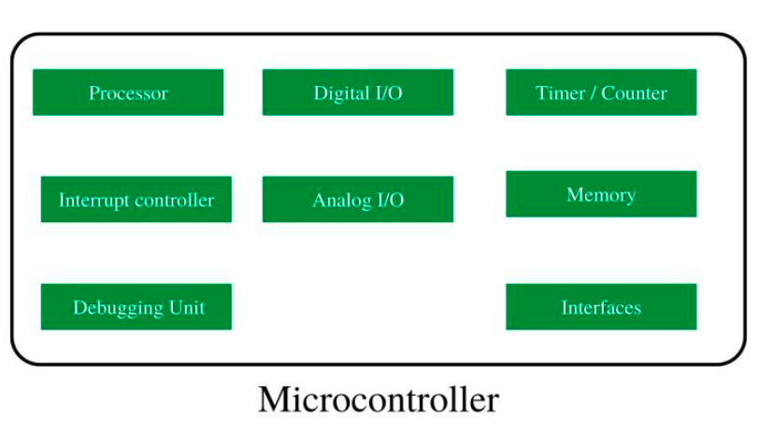
Figure 1.0: Shows the components of a typical microcontroller
Available At : https://media.geeksforgeeks.org/wp-content/uploads/20221101160839/Screenshotfrom20221101160826.png

Furthermore, diving into a more specific microcontroller that will be used in this project specifically the ESP32 model where according to Hercog,D. et al. published in July 2023 is a powerful yet cost effective hardware to develop Iot applications. This microcontroller was developed by the Esperrif Systems Company form Shanghai China, which had a dual-core processor, Wi-Fi and Bluetooth for connectivity and a number of general purpose input/output Pins. There are a variety of ESP32 models with some even having built-in sensors which helps with the integration of the sensors for the IoT systems.

2.1.2 Sensor
According to an article by Javaid, M. et al. in 2021, sensors are devices that have the capability to detect changes in the environment and capture the signals. The sensors will process the signals captured through the microprocessor and then send out information as an output to other assigned devices.

There are two main types of sensors which are active sensors and passive sensors. Active sensors require power for it to function which includes GPS and radar are some of the examples of active sensors. On the contrary, passive sensors or otherwise known as self-generated sensors do not require any sort of external power in order to produce an output which includes thermal sensors, metal detection and so on.

Sensors are applied in different settings with one being specifically the image sensors where it converts images into electrical signals that can be stored or displayed which can be found in digital cameras medical imaging and even biometrics which will correlate to our project as our Attendance System use AS608 fingerprint scanner is used as biometrics.

2.1.3 Biometric Fingerprint
According to Jain, A., Hong, L. and Pankanti, S. in 2000 that biometric identification is where the process of identifying an individual based on their biometric characteristics. Moreover, according to a paper published by Lourde R, M. and Khosla, D. in 2010 stated that the enrolment and authentication are the main process that is involved in to biometrics system. It is done by associating the individual with an identity that has been previously verified before. The most ideal biometric should be a characteristic that every person has but is still unique, permanent, unchangeable, collectable, easily quantifiable and readily available to a sensor. In addition to that, the biometric device is just as important where the performance as in the accuracy, accountability and circumvention will also be considered. Therefore, that is why the fingerprint is suitable for the attendance system of this project as the fingerprint is the pattern of on the surface of a fingertip and is distinct where identical twins have different set of fingerprints and so impersonation will be less likely to occur.

2.2 Web Application
A web application is a platform where to requires the help of a web browser like google, Firefox, Microsoft Edge and so on, in order to access the page. Web applications can vary in complexity from a simple article website to an online shopping website that can be used to serve different purposes which can include e-commerce, informational, entertainment and much more.

As mentioned by a thesis written by Pokharel, S. in 2020 is that the web applications is very much liked upon as it is accessible in a sense that developers will not run in to compatibility issues because compared to desktop applications as it only requires the help of a web browser unlike desktop applications which require developers to develop an application for different operating systems as stated in the thesis
Hence, this is the reason why the web application is suitable for the project as the system must be stable to be accessible to all lecturers and administrators with different computer devices. The web application that will be developed in this project will have both front end and back end as this system will require login and a database to store data.

2.2.1 User Interface Display
According to Jacob, R.J.K., Profile, V. and Metrics, O.M.A. in 2003 stated that the user interface is the part where the system interacts with that user which includes anything that is visible to the user. A proper user interface should not be considered after the system has been developed but should be considered at the beginning of the system design.
Additionally, a user interface design should be focused on the users which includes the terminology that they use and the capabilities and limitations that they possess instead of the developers. It should also be known that the design of the user interface should be based on the research of facts and not solely taking in the opinions of the users as emotions can change but behaviours. Moreover, the interface should not only consider the general users but also users that may have disabilities regardless of physical or mental disabilities.
Furthermore, according to another paper published by S.Sridevi in 2014 have stated different design principles that needs to be followed which includes the following:
- Maintain design consistency across the applications where the design rules are the same throughout the web application
- Implement interactions that does not force the user into performing undesired actions. Foe instance, the application does not forcefully spell check texts if the user decides to edit the text.
- Allows users usage to be interruptible and undoable where if users decides to perform other tasks the current tasks would still remain when the users decides to come back to the task and also allows the user to undo an action.
- Hide technical operations from the casual user where the users should have to see the operations behind the web application such as the operating system and file management functions.

2.2.2 Handling of Backend
Once again according to Pokharel, S. in 2020 it has been said that backend is a portion of the web application that is responsible in handling every logic of the application which includes the database interaction, the authentication of users accessing the web application, the configurations of servers and much more.

There are multiple different backend languages that can be used, but the one that will be looking into will be PHP as it is the one that will be used in this project. According to an article written by Ratschiller, T. and Gerken, T. in 2000 it is said that the language PHP was derived from other languages like C, C++,Pascal and so on. PHP allows the ability to develop an interactive website however, for it to run it requires a server environment as it is an interpreted language which means it does not compile like other languages like Java and Python. PHP requires the connection of a database in order to perform activities like retrieving and storing data in the database.

The backend will retrieve the request of the user and will then accept the request and follows the necessary procedures to execute the functionally where the users will not see. It is also said that when implementing the backend, one must use multiple files in a project so that it breaks down the source code for better maintenance and also improve productivity as different members of the group can simultaneously work on the project without having to merge the code into one file.

2.4 Web Server
This section of the documentation will be discussing about the web server where According to Andersson, M. in 2005, the web server allows the access of documents stored on the server/ The documents can include anywhere form Hypertext Markup Language (HTML) files, script. The web server uses the Hypertext Transfer Protocol otherwise known as the HTTP to allow the capabilities to communicate between the clients and the server.

When a document that is stored on the webserver is requested, a HTTP request will be sent to the server where the request is encapsulated in a TCP segment. The TCP contains information like the port address and the TCP itself is encapsulated in IP packets that contain the IP address of the server.

There are many web server but one particular is called the Apache web server which according to the paper is a popular web server as it is free to the public to use. The Apache works using threads and when the web server receives a request it will assign one of the threads to execute the request throughout the request lifetime and if the number of threads has reached the limit of number of threads that are allowed to run simultaneously the rest of the following request will be rejected automatically.

2.4.1 XAMPP
According to a paper published by ER. Saurabh and Er. Satinderjit Kaur Gill in 2014 it is having been stated that the word XAMPP comes from an acronym where Cross-Platform for X, Apache for A, MySQL for M and PHP for P and Perl for P which provides the necessary tools to develop a fully functional web application in one go.

XAMPP is considered a simple, lightweight Apache which allows an extremely easy creation of a local web server for developers which is why it is a popular web server that is used among the developers. It is also a cross platform which indicates it is compatible with different kinds of operating systems which include Linux, MacOS and Windows. XAMPP is also easy to use and is perfect for beginners as it contains all the common web development tools into one package.

All in all, XAMPP is considered a great web server tool among web developers. That provides easy implementation which is targets introduction tools to developing a web application.
2.3 Database Management System
This section of the documentation will be discussing about the database management system where helps make the management of data easier because it is a centralized management which includes it reduces the redundancy data to make it more efficient and make sures the data or information is up to date. As for this documentation will be covering the relational database management system is where the handling of data stored in tables.

Although there are different types of databases, this documentation will only look into real-time and relational database as those are the only types of database that will be discussed in the following subtopics.

According to Khedkar, S. and Thube, S. in 2017 stated that real-time database is a cloud-hosted database where the data is stored in a JSON format and synchronized throughout the clients.

As for relational database requires one filed to be unique identification or otherwise known as the primary key where no two records have the same value which then allows the connection of tables by using the foreign key. Furthermore, database queries can now be utilized to retrieve, update, and insert records of the data stored in the database.

2.3.1 MySQL
According to Steve Suehring, S. in 2002 it is said that the MySQL is an overall and it also said to offer stability, support and low cost. In has been said that MySQL performs well in web applications. MySQL is also open source where everyone is able to download and utilise MySQL for free. MySQL also scales well for both small and large applications where it is able to accommodate up to a total of 8 terabytes per table.

2.3.2 Firebase
Although firebase has different services including analytics and cloud messaging, there is one particular services known as the real-time database that will be looking into. This database according to Chougale, P., Yadav, V. and Gaikwad, Dr.A. in 2021 it is said that it uses noSQL and that the information stored in the database is in real time which can also be accessed even offline. However, there is a drawback to this is the costs where it only provides 1GB of free storage and exceeding the limit requires a subscription of one of the plans where on is known as the Flame Plan which costs $25 every month that gives a total of 2.5GB and the other plan is known as the Blaze Plan which requires the payment of $5 for every GB of storage used.

2.3.3 Oracle
According to Steve Suehring, S. in 2002, that is had minimal disadvantages. It is said that the administrators that uses the Oracles database server had reported that it rarely fails. However, the Oracle has been said to require hardware that is high end in order for it to run on a more acceptable level.

2.3.4 Microsoft Access
Microsoft access is a relational database management system that has been that is preloaded into to Microsoft 365 package and is a great introduction to developing a relational database. However, Microsoft Access has been known to not scale well to larger databases which is not ideal especially including he proposed the project as it has to handle with all the information of students and lecturers because as the data increases, the performance will start to decrease which for example would in result in a slower retrieval of data.

2.3.5 Comparison
It is without a shadow of a doubt each database provide different features and each with strengths and weaknesses. However, deciding on anything does not solely look into the best one but should look into the most suitable one based on the needs and requirements of an individual and so in choosing a database management system is no different.

First and foremost, in terms of scalability Firebase, Oracle and Firebase are good at small to large databases but with Firebase having to purchase the service if the database is too big and so MySQL and Oracle are a more viable option as they are scalable and more cost effective. However, as Oracle requires hardware that is deemed high end in order of the database to be able to run smoothly and perform at an acceptable level.

Therefore, after looking into the different databases that were discussed and taking into consideration of the other components of the it is clear to see that the MySQL is chosen for this project as it is compatible with the web server that was chosen and on top of that it is also cost effective as it does not require payment of any sort to utilize this database.

2.5 Security Risks
As IoT is a popular technology where it allows for essay connectivity and convenience and web applications too have brought immeasurable convenience and functions. However, just like every technology that was introduced there will be bound to have security risks that need to be addressed as every technology has its weaknesses that where individuals with and intentions will try and exploit. The following subtopics will discuss more on the security risks and some of the practices to help the security of the system.

The security risk is a serious topic that needs to be addressed as it is important as it could greatly impact the outcome of the system. The outcomes can include the confidence of users in using the system and the system is less prone to an attack.
2.5.1 Security Risks in Internet of Things
This section of the documentation will be discussing about the where according to a paper published by Thilakarathne, N.N. in 2020 where it has been said that IoT is considered the future of the Internet where it provides seamless connection and automation and as more and more devices having the ability to connect to the network it ensures a more convenient and efficient IoT application.

There are 3 main layers that needs to be discussed regarding the security risks however before that here is a brief description of each layer to have a better understanding:
- Perception Layer:
This is the lowest layer where it consists of sensors and actuators and other physical devices. The primary function in this layers is to capture and collect the data in the environment such as the temperature, humidity through the sensing devices like the RFID, thermal detectors and so on.
- Gateway Layer:
The layer is in between the two layers and its function is to manage the communication between the Perception layer and Cloud Layer. It acts as a middleman that helps transmit and process sensor data.

- Cloud Layer:
This layer is located at the very top where it has the responsibility to deliver the user the services in the system. This layer provides the business value to the IoT system that gives users the application services that was offered.

Now, after the brief introduction to the layers, it is now time to discuss each of the layers’ security risks that comes with it.
- Perception Layer:
- Denial of Service (Dos) Attack:
This attack involves the attackers would overwhelm the sensors as the sensor usually have a limited amount of capacity. This attack causes the sensors to become useless as a whole.
- Hardware Jamming:
This attack involves the attacker physically damaging the nodes where they modify the hardware components which then causes the nodes to function properly.
- Insertion of Fake Nodes:
This attack involves the attacker to install fake or malicious nodes into the network which allows the attacker to gain unauthorized access to the network causing the attacker to have control of the network.
- Brute Force:
This attack involves the attacker forcefully braking into the nodes as the nodes are known to have a weaker computational power and causing the attacker to easily force their way and have control access.

- Gateway Layer:

- Session Hijacking Attack:

This attack involves hijacking the sessions which allows them to have unauthorized access to the network and possibly extract sensitive information.

- Man-in-the-Middle Attack:
This attack involves the attacker intercepting the between the communication channels and sensing nodes where the attacker has the chance to obtain information that is considered classified if there is no proper encryption applied

- Cloud Layer:
- Attack in Virtual Machine:
This attack involves the security breach in the cloud virtual machine side and could cause the failure of the entire system.

- Application Layer Attack:
This attack involves the attacker to manipulate the protocols of the application layer which then allows them to gain access to the IoT network.

After all the potential security risks in boils down to the main issues where the unauthorized access is involved as this a very serious matter that could lead to a catastrophic outcome whereby the attackers are able to capture and extract sensitive information reading the users. This causes the users to lose confidence in the system and may stop using the system all together which will then cause the business value to diminish and unable to benefit from the system.

Moreover, there has been a case that was stated in the paper where it is known as the Mirai Attack which occurred in 2016. This attack had caused a major Distributed Denial of Service attack (DDOS) that affected major platforms and services across North America and Europe. This in turn caused many of the multinational industries, social media and even many government services to be inaccessible. The incident was then investigated and had discovered that the attack stems from the IoT devices around the world which was compromised by a malware which was called Mirai. The IoT devices include cameras, printers, residential gateways and baby monitors. The owners of these devices were unaware that their devices were infected with this malware. Thus, this case provides a great example to measure the magnitude and severity of the potential harm if IoT devices have been compromised which gives more reason to protect these devices.

2.5.2 Security Risks in Web Application
This section of the documentation will be discussing about the security risks inweb application where it has been mentioned before, web applications play an important role in allowing interconnectivity to the digital world that provides different functionalities and services. However, web applications do also come with its risks in the security side. Thus, this subtopic will identify and discuss on some of the security risk of web application.
According to a paper published by Chaudhari , G.R. and V. Vaidya , Prof.M. in 2014 have stated that the web application vulnerabilities included the following:
- SQL Injection:
This attack involves the attacker injecting a code which then allows the attacker to obtain sensitive information form the web server’s database. This attack is caused by user input where there is no proper validation of the input which then allows the malicious input to flow into the SQL query.

- Cross Side Scripting(XSS):
This attack occurs when the application is processing the data supplied by the user from the web pages without properly validating ad escaping that content. Thus, the attacks injects malicious scripts to the storage media which causes the session to be hijacked and bypass security defences.

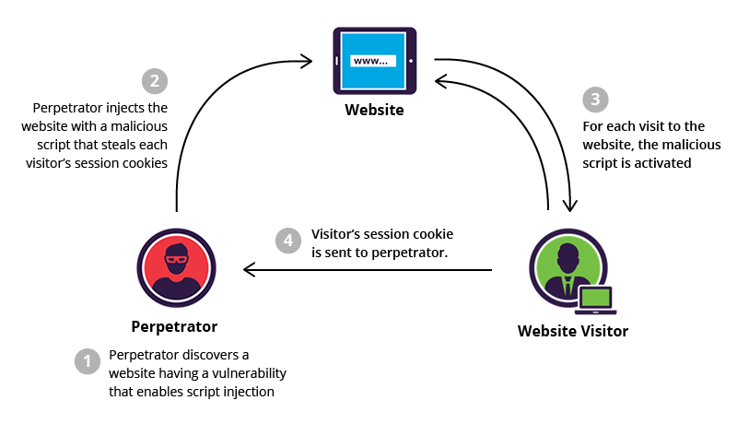

Figure 2.0: Illustrates the Cross Side Scripting Attack
Available At: https://www.imperva.com/learn/wp-content/uploads/sites/13/2019/01/sorted-XSS.png

- Broken Authentication and Session Management:

It is causes by the improper application of the authentication and the management of the sessions Therefore, the attacker uses the process of the authentication and session management functions against the system by finding loopholes that allows the attacker to obtain the sensitive information which includes the user credentials, session IDs and much more.

- Cross-side Request Forgery:
This attack involves a type of exploiting where the attackers manipulates the victim into sending. The attacker has the capabilities in crafting a request that cannot be differentiated with the legitimate request.

- Security Misconfiguration:
This attack occurs where there is improper configuration which then causes unauthorised access of the system data or even the functionality and in the worst case entire comptonization of the system. This vulnerability can occur at any level of the application stack which includes whet web server, application server, database server and so on.

- Using components with known Vulnerabilities:
This attack is caused by multiple vulnerabilities that are known and present which includes external libraries, frameworks and other software that has full privileges access. Developers sometimes are even unaware of these issues which causes the vulnerability to be fully exploited by the attacker

- Malware:
This attack involves infecting devices with malicious code usually by user interaction by using deceptive tactics that tricks users into downloading the malicious code into their device through the website or even using an already compromised account to impersonate as the owner of the account to trick the victim’s friends and family to click on a malicious link that contains a malware. It has been stated that as every malicious is resolved through updates comes a new malware that finds a new way to infect and compromise devices.
Thus, when developing a web application developers should not only focus on the efficiency and convenience of the web application but should also take into consideration of the vulnerabilities and security risks that comes with the convenience and efficiency so that the issues can be identified and addressed to improve the security of the web application. The application must be able to find a balance between efficiency and security where users are still able to remain efficient enough while also having

2.6 Security Best Practices
Due to the security risks that have been mentioned before, this subtopic will be discussing on some of the practices that should be implemented into the system to better improve the security of the system. This is an important step in developing a system as a system that has little to no security practices discourages users from using the system as it gives the users little to no confidence of the system knowing that there is no effort in improving the security of the system.
The security of the system must have the follows a simple principle where it must have availability, confidentiality, authentication and non-repudiation.

The 5 principles of security:
- Availability
The system must be available for users for 24 hours and even if the system is under attack must still be able to operate. For example, acquiring a redundant system sot at if the main system fails it is able to still provide the services to the user by using the redundant system.
- Confidentiality
The data in the system must be kept secret and cannot be simply accessed by anyone. For example, using encryption for it to generate a series of long charecters which if attacker does obtain the data it will be unreadable and render the data to be useless for the attacker.

- Authentication
This involves verifying the identity of an individual before giving access to the system. For example, the biometric fingerprint scanner that will match the input of the fingerprint with the fingerprint stored in the database.

- Non-repudiation
This involves providing undeniable evidence of the involvement of the user in the activity. For example, digital signature where when a user sign a document digitally the document will then be hashed converting the document to a series of number and character which will then be encrypted. If there is any modification of the document the hashing of the original document compared to the hashing of modified document will not match which further prompts an investigation.
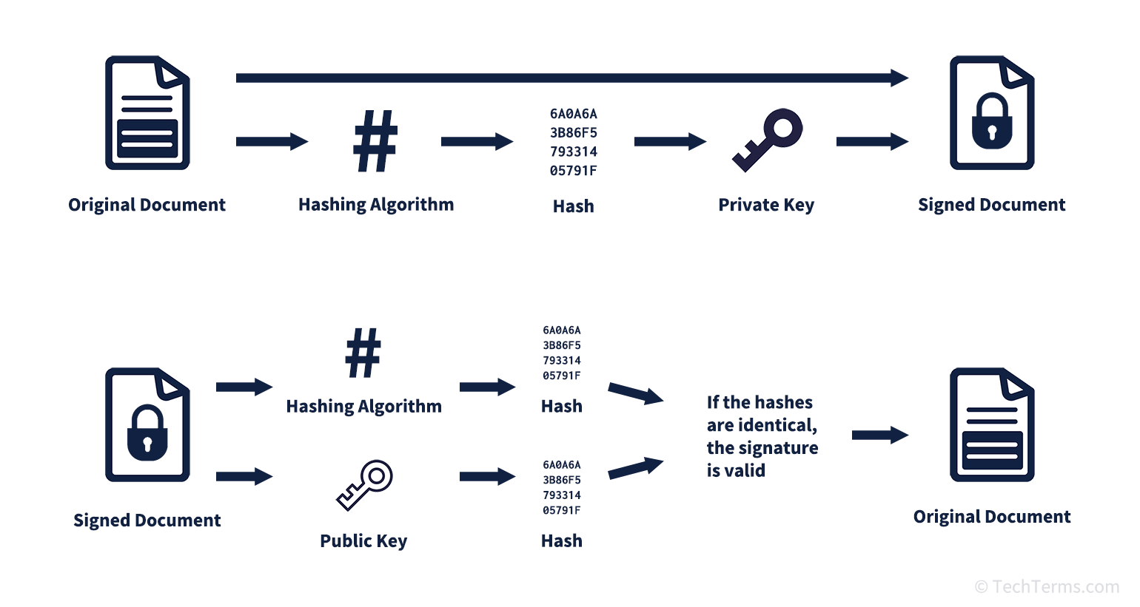
Figure 3.0: Illustrates the process of digital signatures
Available at: https://techterms.com/img/xl/digital_signature_796.png

2.6.1 Sign In of users
One of the security measures which will be implemented is the login of users where only registered users are only allowed to access the system. Therefore, only users that were registered into the database can access the system by entering a username and password to the login interface. Hence, when this security measures are applied into the project that was proposed, it will then prevent any unauthorized individuals from accessing the attendance system.
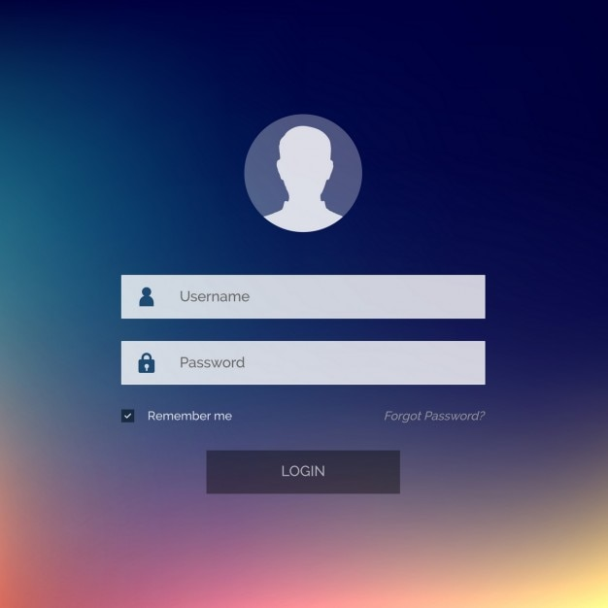
Figure 3.1: Shows an example of the login interface
Available at: https://www.google.com/url?sa=i&url=https%3A%2F%2Fwww.freepik.com%2Fvectors%2Ffacebook-login&psig=AOvVaw1KerLDe4oMHzIj6aUcidYJ&ust=1708081434412000&source=images&cd=vfe&opi=89978449&ved=0CBMQjRxqFwoTCIDI66qZrYQDFQAAAAAdAAAAABAK

Moreover, during the creation of the password for the account should have some validation where it checks if the password has the characteristics like at least an 8 character long password, at least one Special character, at least one numeric number, at least a lower case and at least one upper case. This then buys time and ensure that the password cannot be easily figured out by the attacker.

2.6.2 Least Privilege Access
This practice is one of the fundamental cybersecurity practice where it involves all the users of the system which aims to help improve the security of the system. The structure of this practice through the users which will be given the minimum access to some of the features to only be able to perform the necessary tasks based on their roles. For example, one of the users of a system is the human resource employee and their role is to manage of employees and he/she will only have access to the employees’ information like their names, phone number, email, position and so on. By implementing this practice, it will be able to reduce the attack surface of attackers. This practice is to make sure that the users do not have unnecessary access rights to perform any unauthorized activities. If the system does get compromised the attacker would have a limit which in turn minimizes the impact of the unauthorized access. Therefore, users are still able to remain productive while also having some security in using the system.

In conclusion, both of these practices that was discussed in subtopic 2.6.1 and 2.6.2 should be implemented to improve the security of the system. However, do note that there are more security practices such as encryption, VPNs, and antivirus software, that need to be considered and implemented as these two practices alone are not secure enough to protect against attackers.

2.7 Disaster Recovery and Continuity

As nothing is for certain and the future has been known to be unpredictable there will be some unfortunate events that could potentially occur that causes the system to be unable to perform proper this can include natural disasters likes floods, fires, earth quacks, data breach and much more. Despite these unforeseen events, users still expect full operation and continuation of the operations of the system with little downtime even though these unfortunate events do occur. That is why it is important to also have a disaster recovery and continuity plan to be able to be prepared if an unfortunate events does occur.

One of the methods to ensure the continuity of the system is to make sure that the system contains multiple backups of everything including the data, disk, servers and system so that for instance, a flood comes and has destroyed the server there would still have backups of the data and system to be able to continue the operations of the system. Not only that, sometimes hardware or software would also fail like for example the file has been corrupted thus if there were n backups put in place that contents inside the file would be lost forever.

Moreover, the data must be distributed across the different data centers. This is due to the fact that if one of the data centers is faced with failure the system is still able to retrieve the necessary data from another data center. For example, if there is a maintenance on one of the server, the system will still be able to continue where they retrieve the data from another server that is from another location.

In conclusion, the disaster recovery and continuity must not be taken lightly as users expect 24 hours of the system to be online and if there is no effort in making sure the recovery and continuity of the system would result in decrease in reliability of the system and thus causes the users to be discouraged form using the system as a whole.

2.8 Case Study
2.8.1 Case Study 1: Application of Internet of Things
According to a paper published by Kiran, S. and Babu Sriramoju, S. in 2018 the application of one of the Industrial Revolution 4.0 technology called the Internet of Things or better known as IoT This case study is to report the application of IoT system by where it explores IoT in both wired and wireless technologies. The author also gave a brief definition of IoT where it involves the interconnection of multiple objects and devices that allows them to communicate with each other through the Internet with little to no human interaction.

The main objective of the proposed system was to improve the nature of human life where the system that had been proposed is a deployment of motion sensors in a room or even an office that senses movement within the area. The information that is detected by the sensors is transmitted to a Raspberry Pi. Then, the Raspberry Pi sends out the appropriate signals to the relays which then control the power output of the electrical equipment that is within the room which includes the lights fand fans. The system that has been proposed has constructed a simple yet effective system the automates the electrical devices based on the presence of a human.

In the paper, it had also discussed the problems of the current smart home application where it utilizes IoT Monitoring System regrading to the IoT application which includes the need of a comprehensive infrastructure in terms of the communication which includes the limitation of the current technologies like Bluetooth. Therefore, the limitations of the existing technologies that were mentioned have sparked the proposing of the automation system instead to overcome the downside.

Not only that, but the paper had also discussed on some of the security concerns specifically related to the IoT applications in terms of the mobile network. The acknowledgment of the vulnerabilities in cryptography mechanisms and to the physical side in terms of security threats. As such the aper explores on the need for that robust security posture in order to maintain the integrity, confidentiality, and privacy of the IoT node.

Moving on, the author had also mentioned briefly about topics including the algorithms , decision trees, rough set theory, and case- based reasoning that gives good summarization of how these components have the potential for further enhancing the capabilities of the IoT applications. Although the techniques that were mentioned were not explored in detail the author had argued the applicability of these techniques to further improve the efficiency of IoT systems.

In conclusion, the proposed system that the author has presented is a good example of an IoT device that focuses on a smart city specially the automation in a home setting which uses the integration of components including motions sensor, relays and a Raspberry Pi. It has been emphasized that the potential of IoT that has the capabilities of enhancing human life. The proposed system that was in the paper together with the consideration in terms of security is a great display of approaching a smart city. It will be without a doubt that IoT will continue to evolve and the components of the IoT used will continue to refine, which then optimize the applications and open up a new endless possibilities for an effective yet efficient smart city.

2.8.2 Case Study 2: Application of Web Application
According to a paper published by Armel, J. in 2014 where it develops an e-Commerce web application for a small start-up freelancing company. This web application will provide the administrator to be able to create the necessary pages for their categories and products and have the ability to input the simple information which can be the name, availability and image of each product. In the users side the web application will offer the basic CRUD operations which stand for Create, Retrieve, Update and Delete operations where the public is able to login and then able to access pages that allows them to filter the products by category as well as make and order which then proceeds to checkout where they make payment of the purchased products with PayPal.

On top of that, the system will have some additional features like authentication and addressing the main vulnerability. The authentication has been stated that the users will first be authenticated if they have any special access privileges where they have the ability to administrate and manage the system if not it will only allow the users to only have access to purchasing page and the purchased history page. For the main vulnerability however, where the author had expressed that the main vulnerability is the targeting of the URL which is resolved by using CRSF token.

The development of this web applications uses different software and programming languages which includes the frontend where they had applied HTML and the database to authenticate the users to prevent unauthorized users form entering the system as well as the Laravel framework for the application of the functions. The paper provided a detailed documentation of the application of each of the software which includes the coding and the database field that was used.

The author had expressed that the use of framework that was chosen for this system was simple and easy to understand compared to other frameworks like .NET that was mentioned in the paper. Not only that the web application mist also have some sort of security to prevent any unauthorized access which could potentially harm the system and the users involved if it is not addressed properly. The author had also expressed that they had struggled to find academic references to the for developing the system as the framework that was used is still considered relatively young.

After having read the paper, it is clear to see that before implementing a web application it also requires some research on the tools that will be used so that the tools are chosen are suitable and easy to implement for a project. Furthermore, developing a web applications does not only involve coding the application but also designing the application which includes its structure, the flow of the application and the relationships and dependencies between each pf the entities so that there is a rough idea and direction of the application to make sure the applications objective has been met. It is also worth noting that despite the successful deployment of a web application it does not just end there, as there is bound to be an area where it needs improvement.

2.8.3 Case Study 3: Application of Web Server
According to a paper published by Ahmed, Md.T., Kabir, Md.H. and Roy, S. in 2022 where they had implemented a web server to a system. The system is an integrated and automated system that is access through the web application that allows student to register as candidates through online and it also includes a management system for form fill-up the final examination which includes an online payment. On top of that the system also provides features like allowing students to download admit card and registration form that had been approved by the relating authorities.
The system is developed by using software like PHP, HTML CCSS , JavaScript Ajac and much more with the web server using XAMPP. The authors had used the XAMPP software to create and manage the SQL database by using one of the features of XAMPP known as phpMyAdmin. The author had documented a well detailed usage of the XAMPP feature used and was able to successfully give a rundown of the application works entirely.

After reading the paper, it has been apparent that the application of web server must not be taken lightly as it the component that allows the web application to be displayed and that it is responsible in managing the database server where it is just as important so that the operations like the management system for from fill up to be made possible.

2.9 Future of Internet of Things and the Challenges
Based on a paper published by Perwej, Y. et al. in 2019 stating that the Internet of Things also known as IoT is growing at an alarming rate in terms of the way humans are interacting with the world and that the advancements in sensor technologies may be the future and the direction of IoT.

The capabilities of IoT have multiple which consists of sending, control where some of device focuses on the speed, credibility, security as well as the privacy. It has been stated that the sensors play a crucial part in enabling these capabilities that allow them to monitor the parameters and are able to execute the intended functions based on the data collected.

The MEMS technology where it is a micro electromechanical device that is promised to have immense potential in the future of IoT as it is able to integrate electrical and mechanical components that is constructed by using micro and nano fabrication techniques. The implementation of MEMS technology varies in complexity from simple structures that do not contain any moving part to complex structures where it incorporates the use of electromechanical systems. This technology plays a pivotal part in terms of the development of sensors which can detect and monitor various parameters which include radiation, temperature , pressure and much more. In an IoT setting MEMS is an enabling technology which provides a compact, affordable high performance sensors and actuators. With the combination of MEMS sensor with the sufficient processing power allows the sensors to be able to capture a vast array of parameters within the environment.

Although the advancements of IoT technology look to be promising there are challenges that need to be resolved in order for the future advancements to be fully embraced to their fullest potential. The challenges include the following:

Maneuverability - Some IoT devices require free movement and changing their IP addresses and networks based on their current locations. Due to this routing protocol becomes a challenge where there is a need to reconstruct the Directed Acyclic Graph or better known as the (DAG) that is responsible when nodes join or leave a network.

Trustworthiness - In some situation IoT system are required to be complete and reliable, especially in crucial moments, for example in a medical setting. Therefore, the IoT systems must ensure a fast and trustworthy in activities like data collection. communication within a network, and decision making because it is essential to ensure the prevention of catastrophic scenarios.

Scalability – As the continues growth of new users with millions or even billions of devices the expansion of the network is inevitable. As such handling of the distribution of devices also serves as a challenge that requires careful design to ensure the ability to accommodate and tolerate the new services joining the network.
Handle – It must ensure ability to handle and manage multiple interconnected devices including microprocessors, sensors and other machines and devices. This can include the ability to keep track of any failure,
Accessibility – It must ensure that both the software and hardware is easily accessible whereby the software must have the capabilities of providing the services needed by users whenever requested and for the hardware includes the connected device are convenient to access with one another.
Interoperability – It must ensure the seamless connection of devices as there are many platforms each with different protocols that need to work together to be able to achieve a successful IoT system.

The future of IoT has an immense potential to foster innovation and allow changes across various sectors including medical, academic, agriculture and so on. Furthermore, as the sensors utilized in IoT becomes more advanced , the IoT devices themselves will enhance the characteristics of interconnectivity, intelligence as well as capability. Furthermore, as the exposure to newer IoT technologies, it will bound to impact the human life to ensure a better living of humans overall. However, in order for the IoT to successfully advancing requires overcoming the challenges including the ones mentioned before where the maneuverability, trustworthiness, scalability handling, accessibility and interoperability much be addressed accordingly.

2.10 Summary
In summary, this chapter has gone through an extensive research and discussions which covered all the components including the main hardware components like the microcontroller and the biometric fingerprint, software components including the database management system, webserver and other, the future direction of the IoT, and even the security issues and some of the practices for better security in terms of the theoretical part and is ready for better implementation of the system during the development stage.

The microcontroller serves as the brain of the IoT device that is in charge of processing data and providing the communication of the device to the database and the biometric fingerprint adds the authentication layer where it allows the fingerprint to be verified before any further advancing of the functions.

As for the database management system and web server

However, as mentioned before with the new innovation of these technologies comes with the security risks of individuals with bad intentions. Therefore, there must be a strike of balance between innovation and security as there are those who will bound to misuse the technology that was introduced. Thus, the security risks and practices were included in this ln this chapter where it explores the types of attacks in both the IoT device and web application
Although some of the components mentioned including the “disaster recovery and the continuity” topic will not be implemented into the project system due to time limitations. However, this topic should indefinitely be implemented in the future. The future of IoT will undoubtedly expand as time goes on.

Lastly is the disaster recovery and continuity where it had covered the important components including the recommendations of implementation of the backups and distributed backups across geographically dispersed locations.
References
Ahmed, Md.T., Kabir, Md.H. and Roy, S. (2022) Web Based Student Registration and Exam Form Fill-up Management System for Educational Institute, Modern Education and Computer Science Press. Available at: https://mecs-press.net/ijieeb/ijieeb-v14-n2/IJIEEB-V14-N2-4.pdf (Accessed: 18 February 2024).
Al-Fedaghi , S. (2021) Developing Web Applications , International Journal of Software Engineering and Its Applications. Available at: https://d1wqtxts1xzle7.cloudfront.net/34633418/Developing_Web_Applications-libre.PDF?1409888955=&response-content-disposition=inline%3B+filename%3Dd_tai_nghien_cu_khoa_hc_CNTT.pdf&Expires=1707814774&Signature=GigIOSXu8sK4Rs4v7eRHBhNmgqBVGBPQadZBm~hvWWzD8lhuJqNnxi8xJu5iy6~l8NJgviB5QVFucUjCqddy-iaPnBuek05Pv3u4MxQPj-tfX0QliPrgzpLwu5SQV6tvrTHZJwHM7XlcbdPRtnWpNa~pF-ftCQARaXIgCVi-ef3am7u-aVZf2WCvBh7Prm9PYF3hzotLCZy5OXLxayPLY-H-Es9vQ8Biazb4rncyT8ummCCpCBqjNkN1P-4Q92ri5Lid~eVbXw5WdtvZChDtxZVjdLDBrYsKgOk99t5cfWBqgPpcQTF0VQ82xugK7VmTKqVQEMzej7B8yo4CSrE8Zw__&Key-Pair-Id=APKAJLOHF5GGSLRBV4ZA (Accessed: 13 February 2024).
Andersson, M. (2005) Introduction to Web Server Modeling and Control Research, LUND UNIVERSITY. Available at: https://lucris.lub.lu.se/ws/files/6091809/625294.pdf (Accessed: 16 February 2024).
Armel, J. (2014) Web application development with Laravel PHP Framework version 4, Metropolia. Available at: https://www.theseus.fi/bitstream/handle/10024/74052/Author.pdf?sequence=1&isAllowed=y (Accessed: 19 February 2024).
Chaudhari , G.R. and V. Vaidya , Prof.M. (2014) A Survey on Security and Vulnerabilities of Web Application, CITESEERX. Available at: https://citeseerx.ist.psu.edu/document?repid=rep1&type=pdf&doi=70ec4794f92eac850d0e76eea4ffb7e54ba94fd4 (Accessed: 18 February 2024).
Chougale, P., Yadav, V. and Gaikwad, Dr.A. (2021) (PDF) Firebase -overview and usage, International Research Journal of Modernization in Engineering Technology and Science. Available at: https://www.researchgate.net/publication/362539877_FIREBASE_-OVERVIEW_AND_USAGE (Accessed: 14 February 2024).
Gokhale, P., Bhat, O. and Bhat, S. (2018) (PDF) introduction to IOT - researchgate, Introduction to IOT. Available at: https://www.researchgate.net/publication/330114646_Introduction_to_IOT (Accessed: 12 February 2024).
Gridling, G. and Weiss, B. (2007) Tuwien, Introduction to Microcontrollers. Available at: https://ti.tuwien.ac.at/ecs/teaching/courses/mclu/theory-material/Microcontroller.pdf (Accessed: 12 February 2024).
Hercog, D. et al. (2023) Design and implementation of ESP32-based IOT devices, MDPI. Available at: https://www.mdpi.com/1424-8220/23/15/6739 (Accessed: 13 February 2024).
Javaid, M. et al. (2021) Sensors for daily life: A Review, Science Direct. Available at: https://www.sciencedirect.com/science/article/pii/S2666351121000425 (Accessed: 13 February 2024).
Jacob, R.J.K., Profile, V. and Metrics, O.M.A. (2003) User interface: Encyclopedia of computer science, DL Books. Available at: https://dl.acm.org/doi/abs/10.5555/1074100.1074893 (Accessed: 13 February 2024).
Jain, A., Hong, L. and Pankanti, S. (2000) Biometric edentification, Digital Library: Communications of the ACM. Available at: https://dl.acm.org/doi/fullHtml/10.1145/328236.328110#body-1 (Accessed: 13 February 2024).
Khedkar, S. and Thube, S. (2017) Real Time Databases for Applications , International Research Journal of Engineering and Technology (IRJET) e. Available at: https://d1wqtxts1xzle7.cloudfront.net/53796550/IRJET-V4I6401-libre.pdf?1499505061=&response-content-disposition=inline%3B+filename%3DReal_Time_Databases_for_Applications.pdf&Expires=1707983305&Signature=W6V~W9ItaviI1bwUlFglMz0rwtiAleLES4lP-9pQAptBbvN0pH-F763wNVa-ZPYBGsittuFjpq36e0OKi~6qmtm94dPk0vDe0uhxFKGteY5RYykShqgvsV3Arfrcrs4GZQu7aJBE0AQqnB8oO~Aj1i0b~7iAPFlM42yVpRlHZS6HDsd42NFAJwaRFk-Nea-o~tjHay2io7aquAq1CdrE31jGqwCa42pZsaWkEdV-oXQBTibvdp~DJMl5C5ggSVx3wOan4LBgFsuCSI3Lm99XLT1IFY9B7vE6Se0dIwL8-ZVuraRLsr-dgu9iiN1Pdt0NkfH4DlvON7vSynpByD6RLA__&Key-Pair-Id=APKAJLOHF5GGSLRBV4ZA (Accessed: 15 February 2024).
Kiran, S. and Babu Sriramoju, S. (2018) A Study on the Applications of IOT, Indian Journal of Public Health Research & Development. Available at: https://d1wqtxts1xzle7.cloudfront.net/59324740/10.A_Study_on_the_Applications_of_IOT_20190520-79027-1xy91js-libre.pdf?1558347229=&response-content-disposition=inline%3B+filename%3DA_Study_on_the_Applications_of_IOT.pdf&Expires=1708032761&Signature=PV4OTW7mQUZzzA6bJWdYIRI9uL-2f1jAiszbkzYvXmjJPGS2VHPs0~VxRScpFq0yCBeJ0~w0XxqET~-Ep-8XZigaKhmsZVMlYFjK~FOSbMWimPPC5nXYbVLabtj3yS~0yXWrBjrkZfq8rUk8YwJXMJAVEL6Z4Uig30OJi0mvlqjhIY~QN0wx~eJVFGpk7YLKz1dnA-AajCkioGElXkid8eUGoQ~xQUP9sQo27pk76u0tzJlvN8Wh7CGOmq~3-ZduMLNjaz8CM7tOMqO5IvB1pR0Ho05sO4lVAxJdFFkD1znGDHZ16nXFIgq5XOEYQIiLKCQ4EzWfNgdwFRPIn3i9qQ__&Key-Pair-Id=APKAJLOHF5GGSLRBV4ZA (Accessed: 18 February 2024).

Perwej, Y. et al. (2019) The Future of Internet of Things (IoT) and Its Empowering Technology , IJECS. Available at: https://d1wqtxts1xzle7.cloudfront.net/64191939/The_Future_of_Internet_of_Things_%28IoT%29_and_Its_Empowering_Technology-libre.pdf?1597561935=&response-content-disposition=inline%3B+filename%3DThe_Future_of_Internet_of_Things_IoT_and.pdf&Expires=1708033359&Signature=hSPnNQjet68ySrfXbAnWcecF3Q2UDDfXEKMN9yokjRztAHp~9IIhqFR-3P711F6hBY000l4d4yeeFWHWY1IvCAIbWViZT5LneA7PZ2GdAikKxHukBRDkCIv0VCk7WZ7U4LADayzK~pls8rlcAqXWTFclNVrFHqt6BiSWh0RnOywcQvi9k9zRFHtxZTs49LCLG4yhaVqFyVwiE7MMkYPV75MIuYIpyBVIA6OK~XXpBVFdbQX0ugFrvBeFzKMVEJq-sJMnrpYrxGuBp2AmVsxc97sjoZPGksipJbPzkyFkB9DQPE3qdUM~NQQ0KUzih9lrnlo88iBeXMnwTG6hKpbSJA__&Key-Pair-Id=APKAJLOHF5GGSLRBV4ZA (Accessed: 16 February 2024).
Pokharel, S. (2020) DEVELOPING A BACKEND WEB APPLICATION AND DOCKERIZING, TURKU UNIVERSITY OF APPLIED SCIENCES. Available at: https://www.theseus.fi/bitstream/handle/10024/342319/Sujan_pokharel_thesis_final.pdf?sequence=2&isAllowed=y (Accessed: 14 February 2024).

Ratschiller, T. and Gerken, T. (2000) Web Application Development with PHP 4.0, New Riders Publishing. Available at: http://diglib.globalcollege.edu.et:8080/xmlui/bitstream/handle/123456789/1065/eBook_Web_Application_Development_With_PHP_4.0_ShareReactor.pdf?sequence=1&isAllowed=y (Accessed: 14 February 2024).
Suehring, S. (2002) MySQL Bible, Wiley Publishing, Inc. Available at: http://box.cs.istu.ru/public/docs/other/_Unsorted/new/Database/MySQL/MySQL%20Bible.pdf (Accessed: 14 February 2024).

Lourde R, M. and Khosla, D. (2010) Fingerprint Identification in Biometric Security Systems , International Journal of Computer and Electrical Engineering. Available at: https://www.researchgate.net/profile/Mary-Regeena/publication/271304334_Fingerprint_Identification_in_Biometric_SecuritySystems/links/580f889708aea04bbcba5a05/Fingerprint-Identification-in-Biometric-SecuritySystems.pdf (Accessed: 18 February 2024).
S.Sridevi (2014) USER INTERFACE DESIGN , International Journal of Computer Science and Information Technology Research. Available at: https://d1wqtxts1xzle7.cloudfront.net/56470200/USER_INTERFACE_DESIGN-332-libre.pdf?1525224701=&response-content-disposition=inline%3B+filename%3DUSER_INTERFACE_DESIGN.pdf&Expires=1708288523&Signature=c4baWUff0SVsDRcaEeTCAN3kJ1pxujuRn~j2qB7XkNzu8LSJ6~74GTFhru60sg2UmeKYswwZLf3eD1l-j2Usw8Xn~NGgMiyURZ9MF9RDVcOue-H-lcZP55JlyY~-mu6DY-x3qEx1NnEilV4ZaQCrJg6fxf72Aln4t9i9UCGTE5O4A8j-lOvW2BqN5v-~wfH2M24RB7HbWFRpY0G1WsxRIwVev4g~3Ay6PrKuV9Zy8LDQ0qn-YmY7YrBRb35A-VVOYeGkeJUZ2galEBOpiHsUNfwO55ghYL5jJCmCldCU1K8mig2OeSWSPli--yFah9Sg3eae-rDmaI-wk1ZgeR5E2A__&Key-Pair-Id=APKAJLOHF5GGSLRBV4ZA (Accessed: 19 February 2024).
Thilakarathne, N.N. (2020) Security and privacy issues in IOT environment, SSRN. Available at: https://papers.ssrn.com/sol3/papers.cfm?abstract_id=3559982 (Accessed: 18 February 2024).

